Assignment – 4

Name:Santhosh M

Reg no: CITC2005211

1. Pull an Image from docker hub and run it in docker playground.

Homepage of Docker hub:

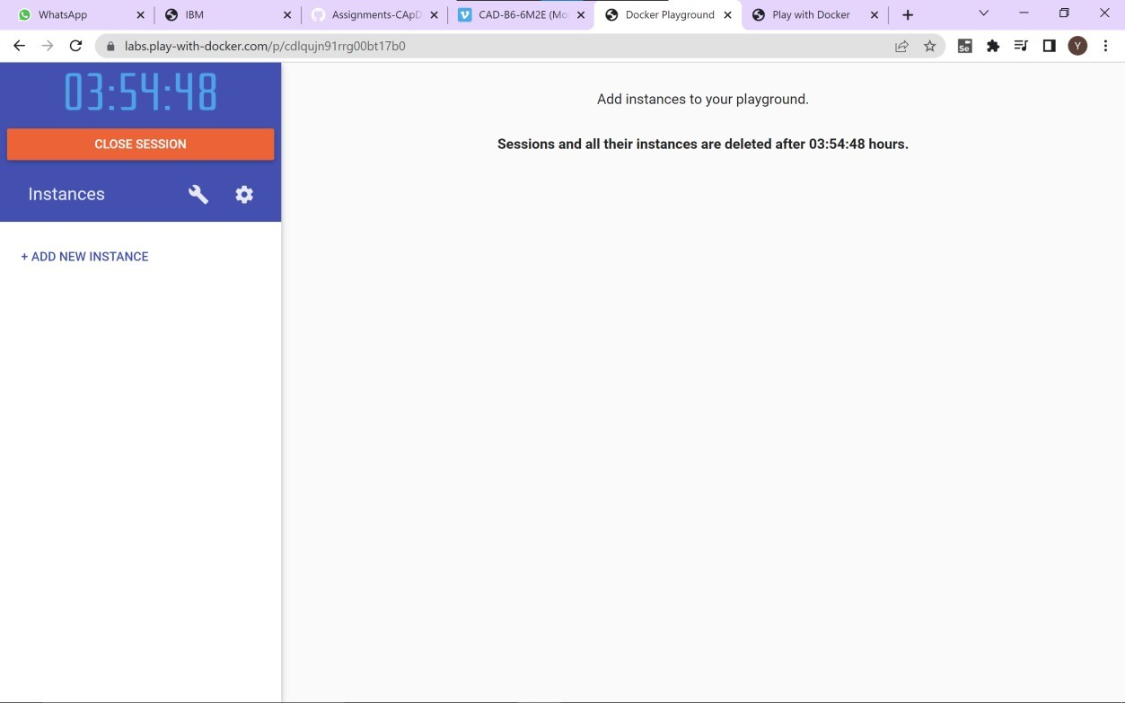

Pulling and viewing the image in the command line of our docker playground interface:

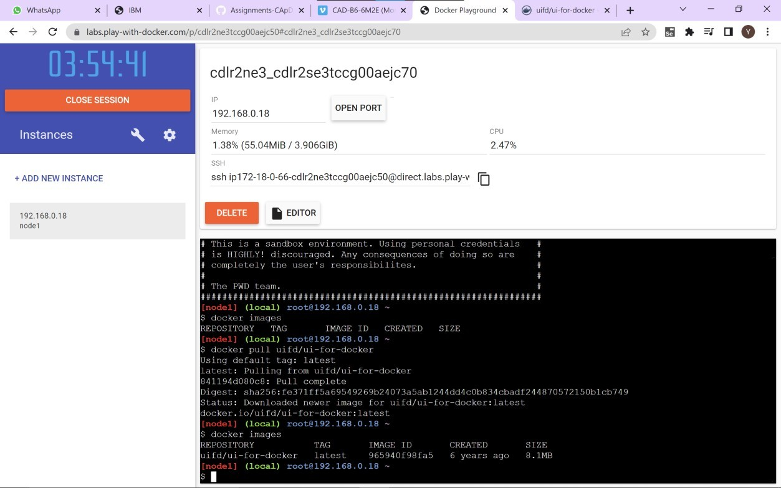

Running the image, (command and the output side by side)

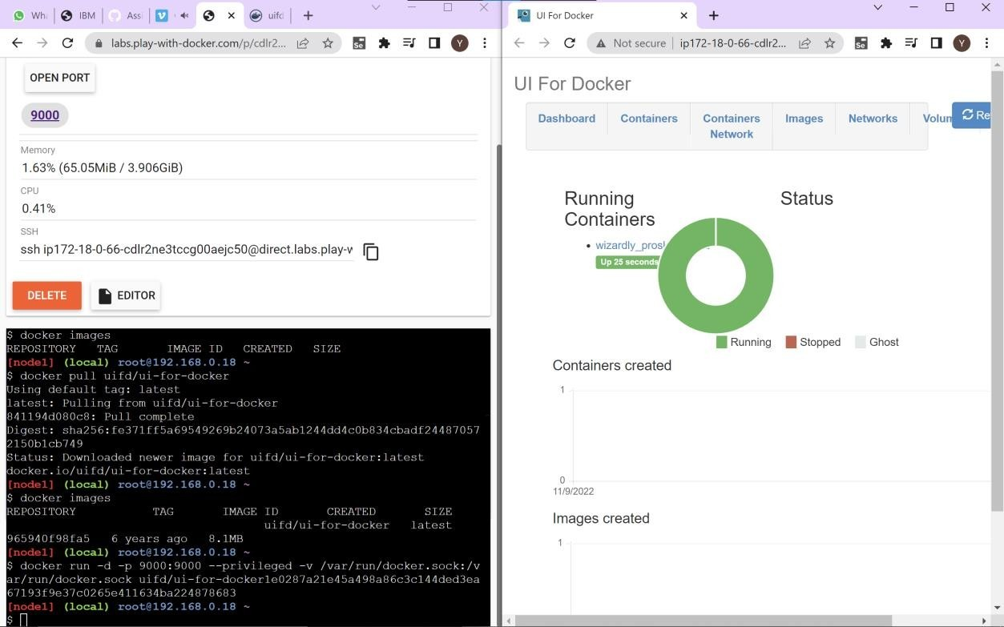

1. Create a docker file for the job portal application and deploy it in Docker desktop application.

Homepage of running docker desktop:

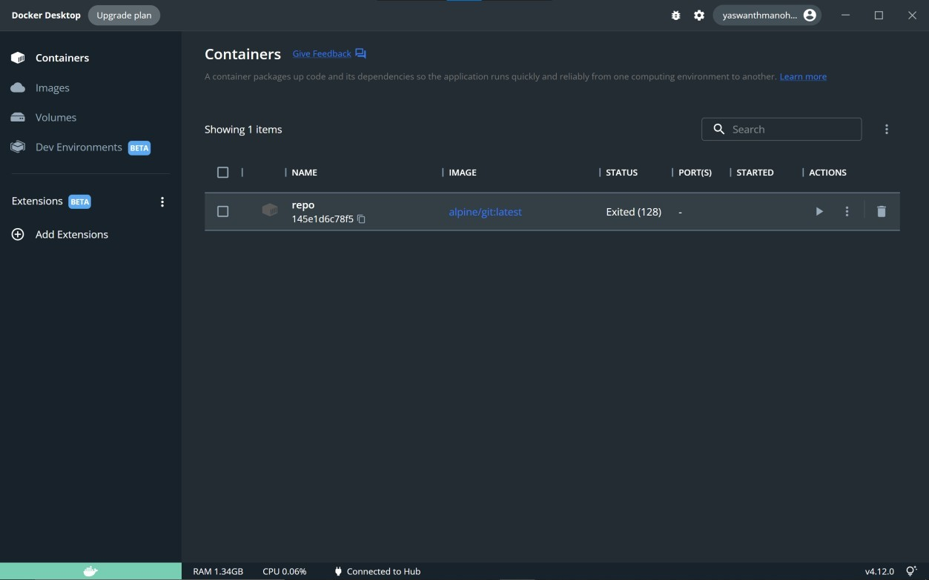

Build an image in docker hub after logging in,

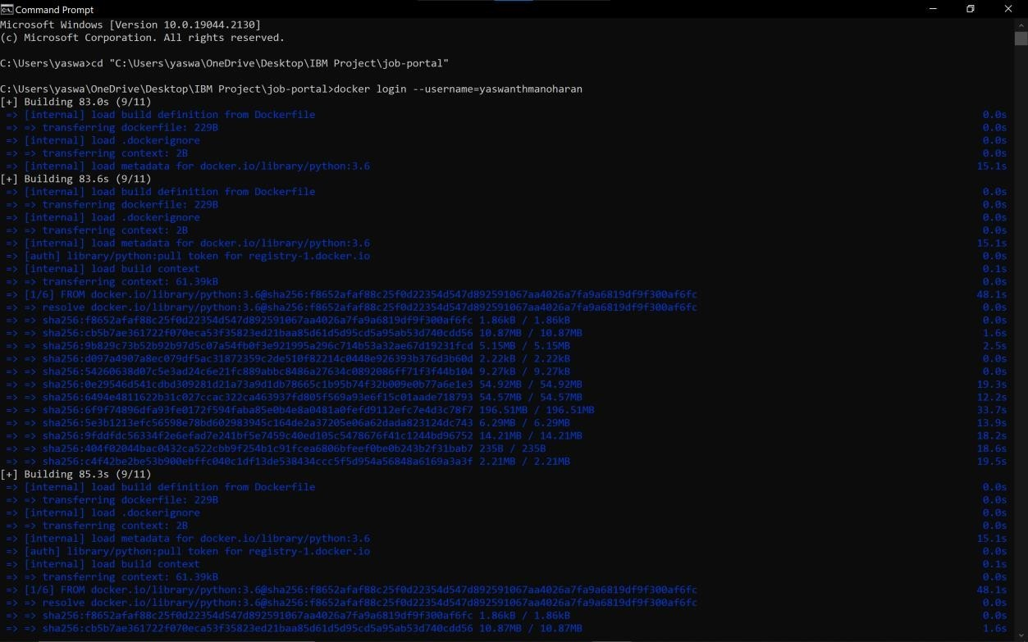

Push the code by creating the tag of image,

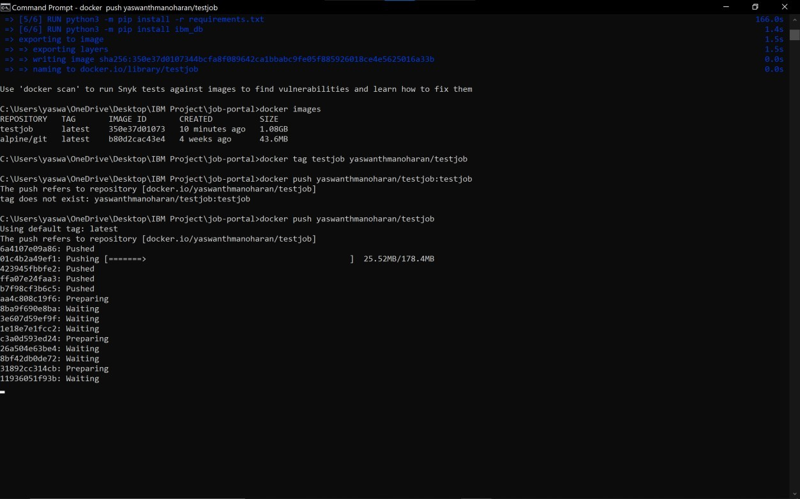

Container for the “testjob” image has been created and deployed in docker desktop.

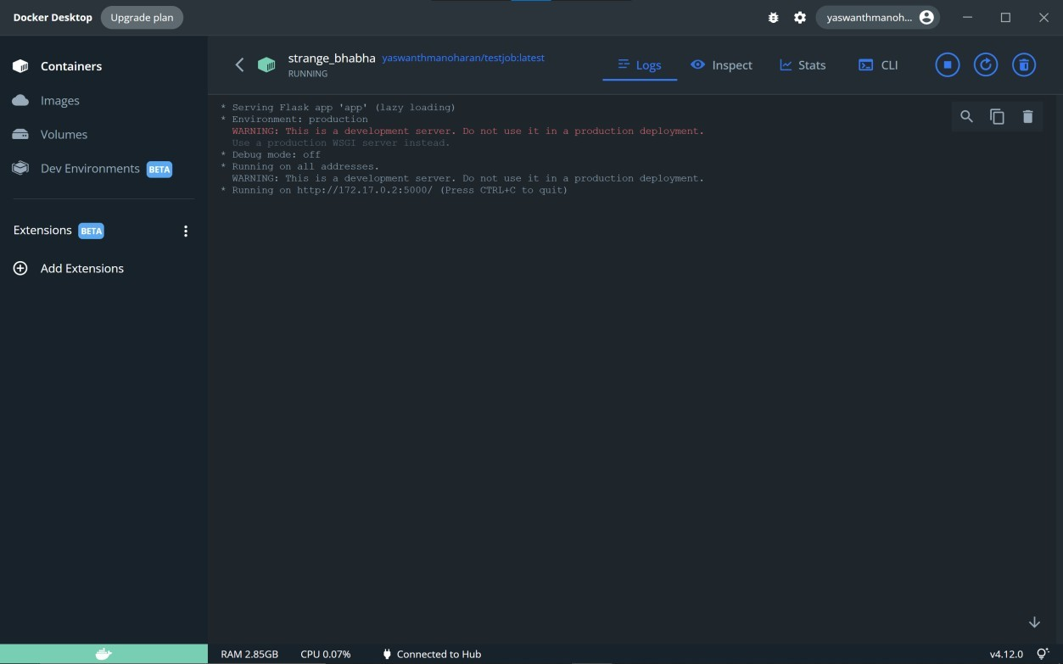

1. Create a IBM container registry and deploy hello world app or job portal app.

Container has been created and both images of jobportal app and hello world have been deployed in IBM container registry.

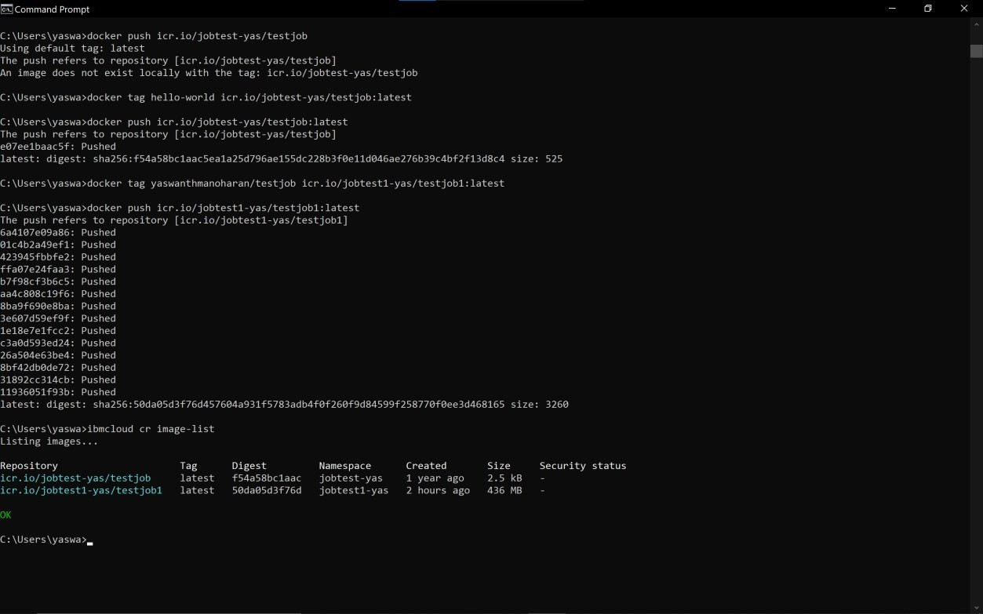

IBM Cloud Registry,

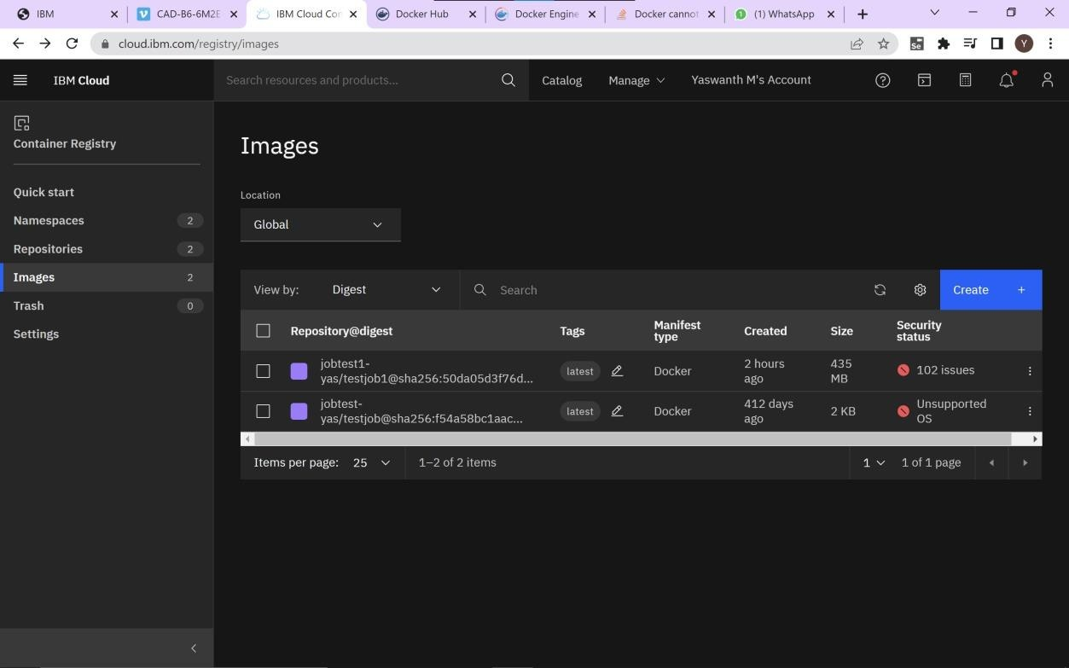

1. Create a Kubernetes cluster in IBM cloud and deploy hello world image or job portal image and also expose the same app to run in node port.

Creation of Kubernetes cluster in IBM Cloud:

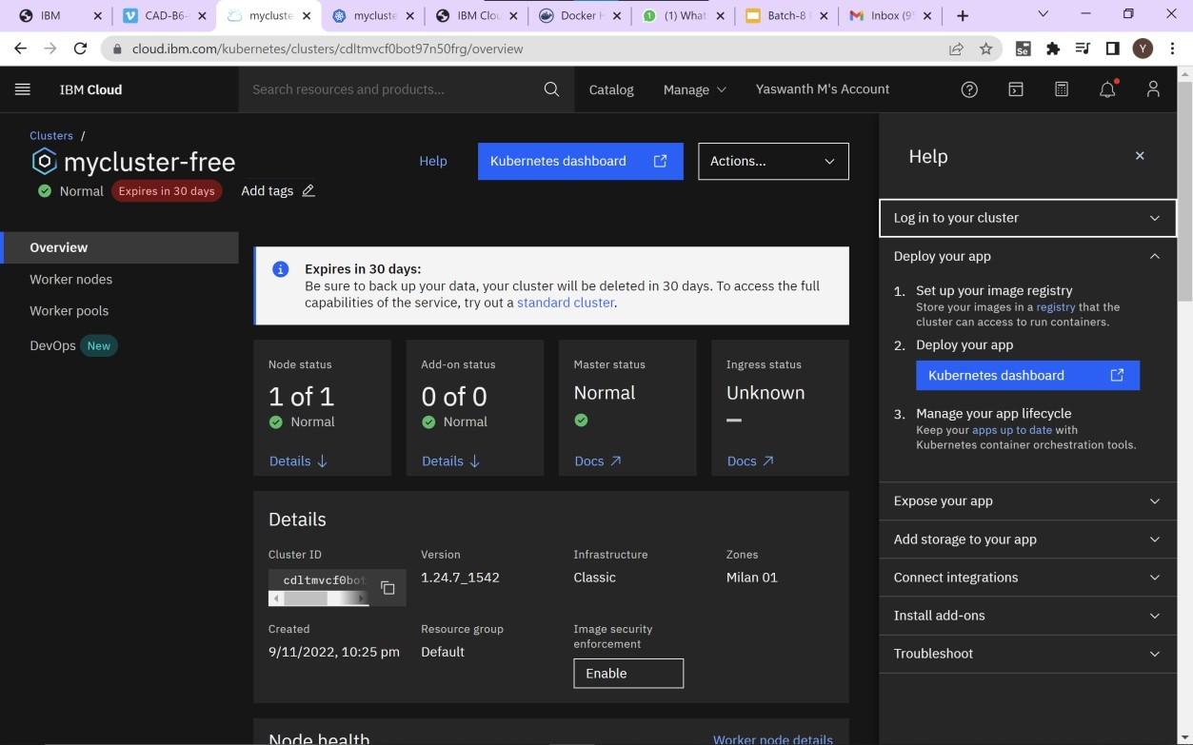

Thus, job portal app is deployed and exposed:

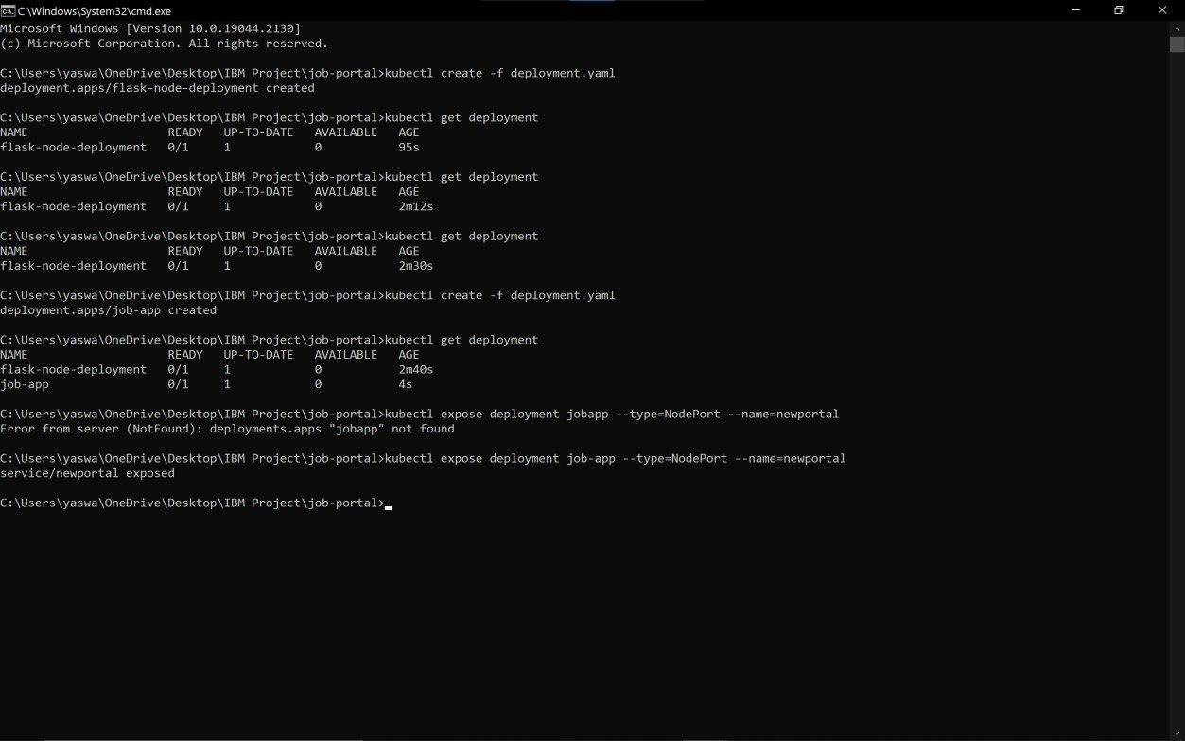

Details of the exposed job portal app.

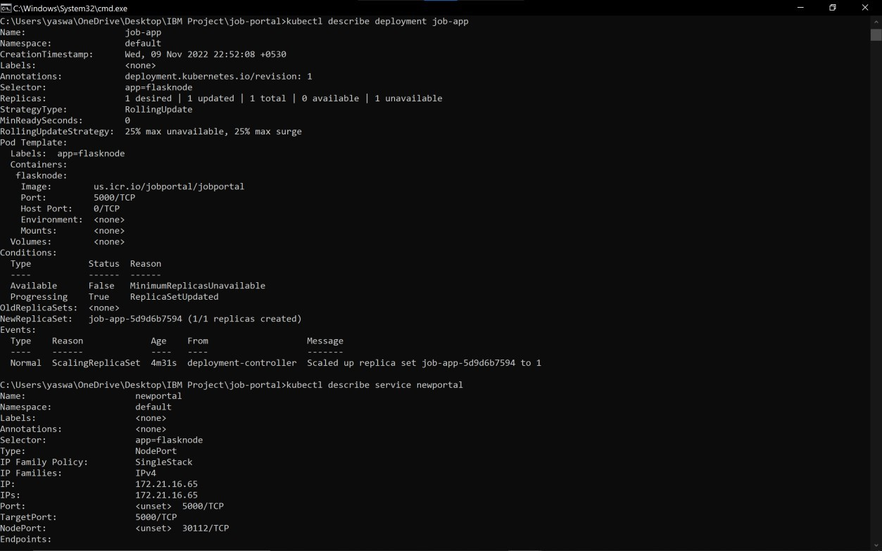

Kubernetes is used to manage the docker images and the number of replicas of each image.